

Vision 360

Mobile Computing Project

Vision360 |Mobile Computing (CSE535) | 02/10/2018

# Final Project Idea

* Vision 360 is a mobile app which focuses on two issues faced by the students and the workers of IIIT-Delhi.
* Our mobile app covers the first issue of student and workers which depends on the complaint register regarding hostel facility (AC, Fan, Tube Light etc.), where the student can register his/her complain from our app and then the FMS admin can assign the person for the particular complain to look in to it.
* The Second issue which our app covers is the hostel payment option, in which the student can upload the receipt of his hostel fee payment and the authorities can verify whether the hostel fee of a particular student is paid or not. If not paid, after the deadline of the fee payment has been met, a mail is sent to all the student as a gentle reminder to pay fees.

# Functionalities Implemented

1. Technical Details:

Our app contains two users:

* + Admin
  + Student

Student Functionalities Are:

* Login to App
* Can access forgot password functionalities
* Can register a complain
* Upload hostel fee receipt
* Change password
* Change contact no
* Change room no
* Have access to notice board
* Have access to utility page
* Have access to profile

Admin Functionalities

* Login to App
* Can access forgot password functionalities
* Have access to list of complains
* Can priorities the complaint depending upon which one is urgent.
* Change password
* Verify uploaded fee receipts of student(Can update status as paid or unpaid)
* Assign complains to the particular worker.
* Admin can close the ticket if the student is not available at the mentioned time at the time of complaint register.
* Admin send a message to the worker who has been assigned the task with issue raised by the student and availability time of the student.
* Admin updates the assigned person name on the app so that it is visible to the student that task is in progress.

Note: Database does not carry any close tickets, once the ticket is closed it get removed from the complaint table.

1. Tools:

* Android Studio
* MySQL

1. Screenshots:

* App Starting Page:

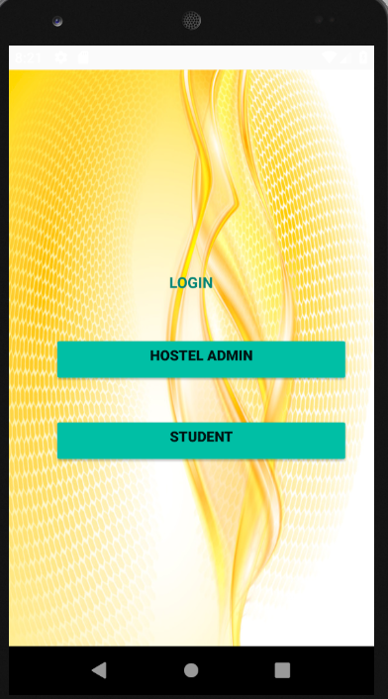

* Login Page

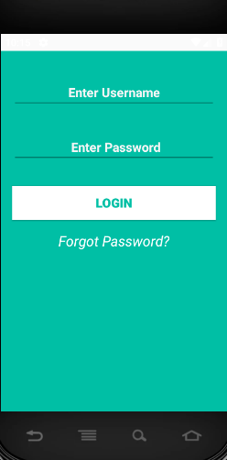

* Home Page

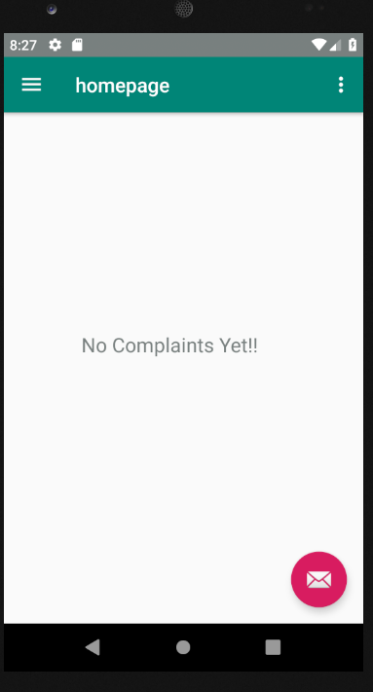

* Student Other Functionalities:

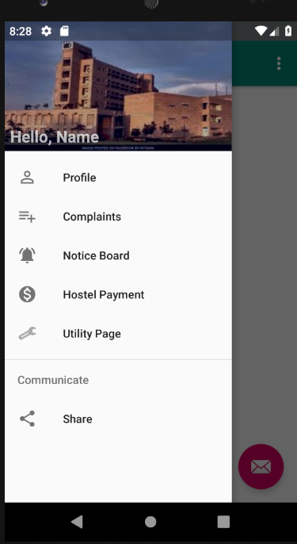

* Profile Page:

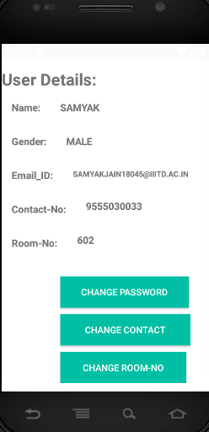

* Change Password:

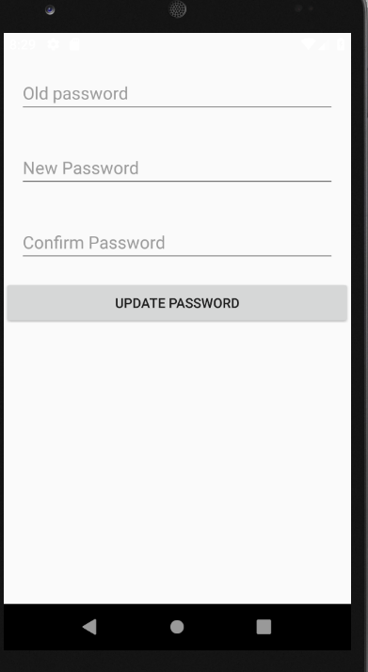

* Change Contact:

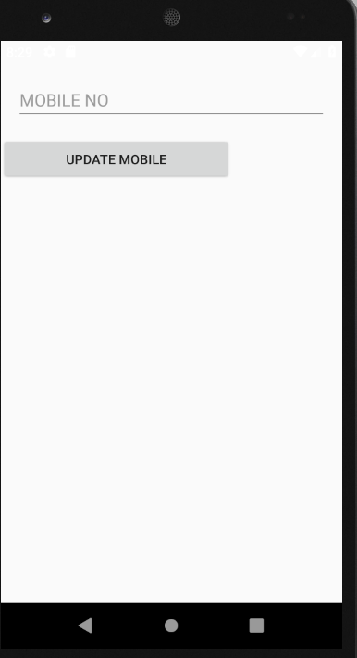

* Change Room No(For student only)

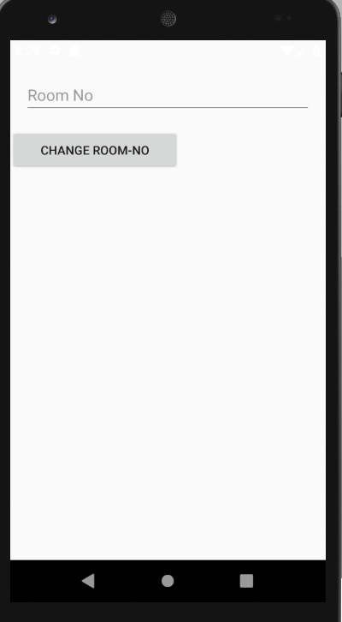

* Receipt Upload page (Student Only)

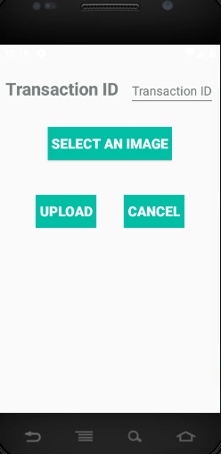 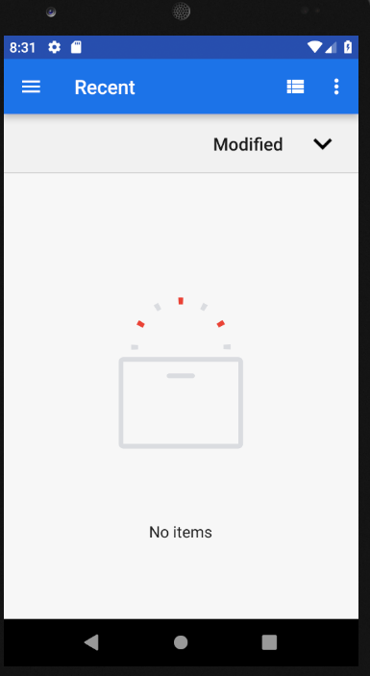

* Utility Page

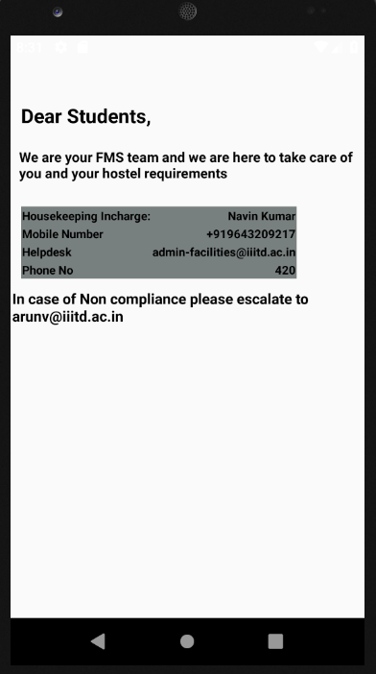

* Student Complaint Process

Date Picker

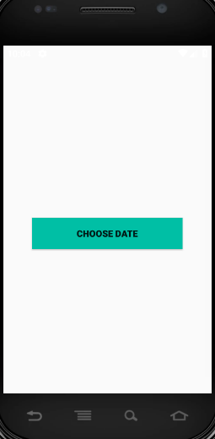

### Calender

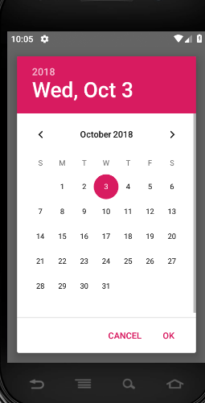

Complaint Page

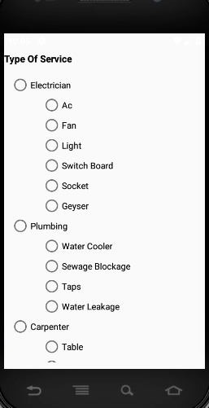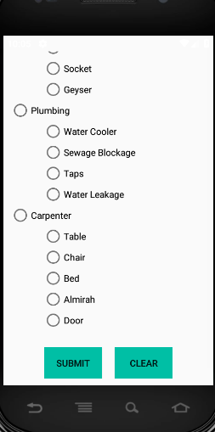

### Work In Progress

1. We are still need to work on admin side details.
2. Notice Board for student is left.
3. Fetching reference id from payment receipt and uploading the fee receipt to database.

### Final Outcome

1. Progress in student side is 80% accept for uploading of fee receipt and notice board.
2. Progress in admin side is 20%.

### Team Members

Samyak Jain – MT18045

Sarika Chaudhary – MT18103

Shubhangi Srivastava – MT18135

Yashasvi Khanna – MT18050

Vani Kaushik – MT18057